Lab-10-2: AWS Networking Checkpoint

8 points

Submission By: 24 Sept 5pm on Teams-> Assignment.

Name:

Objectives

- Setup virtual networking with subnets on AWS
- Deploy web application on aws subnet

--------------------------------------------------------------------------------------------------

Create a Virtual Private Network (VPC) and host a webserver inside a public subnet

In this task, you are going to setup a virtual network in AWS, that has both private and public subnets that spans multiple availability zones.

The network is shown below:

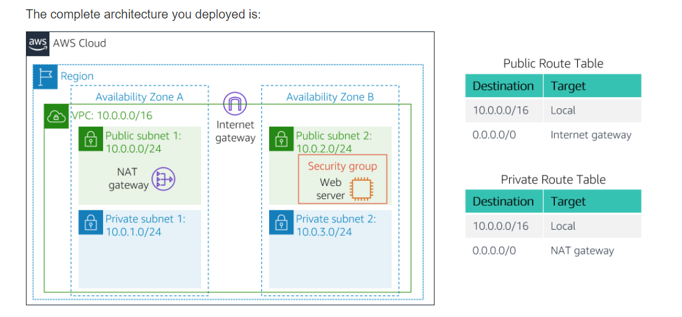

You will do the following to meet the specification provided on the above diagram:

Create a VPC with subnets (1 points)

Create routing table entries (1 points)

Configure a security group (1)

launch an ec2 instance on VPC and access through your browser (5 points)

Create VPC and the Subnets:

----------------------------

1. Open the VPC service from AWS Management Console

2. Launch VPC

3. Create a public ip

4. Select 'vpc wih public and private subnets' from left panel

- vpc name: OPBIT

- public subnet name: Public Subnet 1

- select the first availability Zone

- private subnet name: Private Subnet 1

- select the first availability Zone

- pick the elastic ip

5. Create two more subnets

- select subnets from left panel

- select the VPC you created

- Select second availability Zone for this

two subnets: Public Subnet 2 and

Private Subnet 2

- put corresponding CIDR for these

two subnets (Refer to the diagram)

Create Routing Tables for private and public clouds
---------------------------------------------------------------------------
6. Create Routing Tables
- from left panel select Route Table
- Select the route table that has
Main=Yes and VPC=OPBIT
- Name this route table as Private Routing Table
- Change the subnet association to
Private subnet 1 and Public Subnet 1
7. Repeat step 6 for creating Routing Table for Public Subnets
- Select Main=No and VPC=OPBIT

Create Security Group
======================
Create the security group that allows inbound traffic to http
Launch a Web server instance
================================
Select the Amazon Linux 2
Select t2.micro
Configure instance details:
- set the instance at the public subnet 2 you created
- Copy and paste the following code as User data from
Advanced Details

#!/bin/bash
# Install Apache Web Server and PHP
yum install -y httpd mysql php
# Download Lab files
wget https://aws-tc-largeobjects.s3.amazonaws.com/AWS-TC-AcademyACF/acf-lab3-vpc/lab-app.zip
unzip lab-app.zip -d /var/www/html/
# Turn on web server

chkconfig httpd on
service https start

Add Storage
Add Tag
Attach the security group you created early.

---------------------------------------------
Submission:

Paste the screen shot of the webserver accessed through from your web browser.

